**CS5560 Knowledge Discovery Management**

**In Class Assignment #2**

1. **Generate the following NLP tasks for the following sentence manually**

***Input***:

* 1. The dog saw John in the park
  2. The little bear saw the fine fat trout in the rocky brook.

**NLP Tasks:**

1. 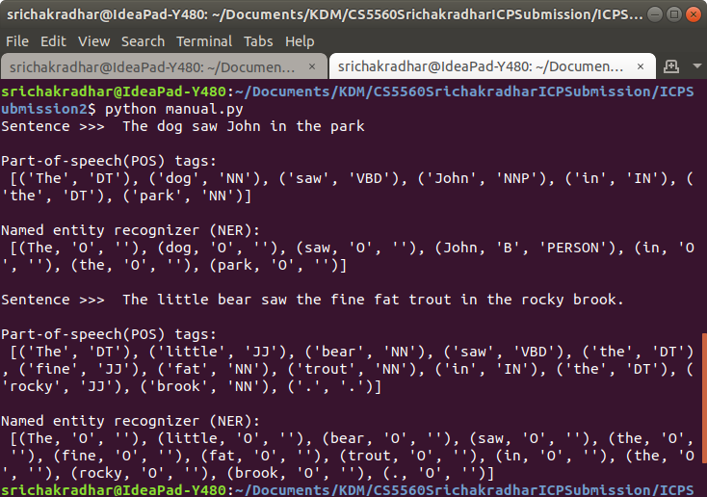*Part-of-speech (POS) tagger*
2. *Named entity recognizer (NER)*
3. *Co-reference resolution system*

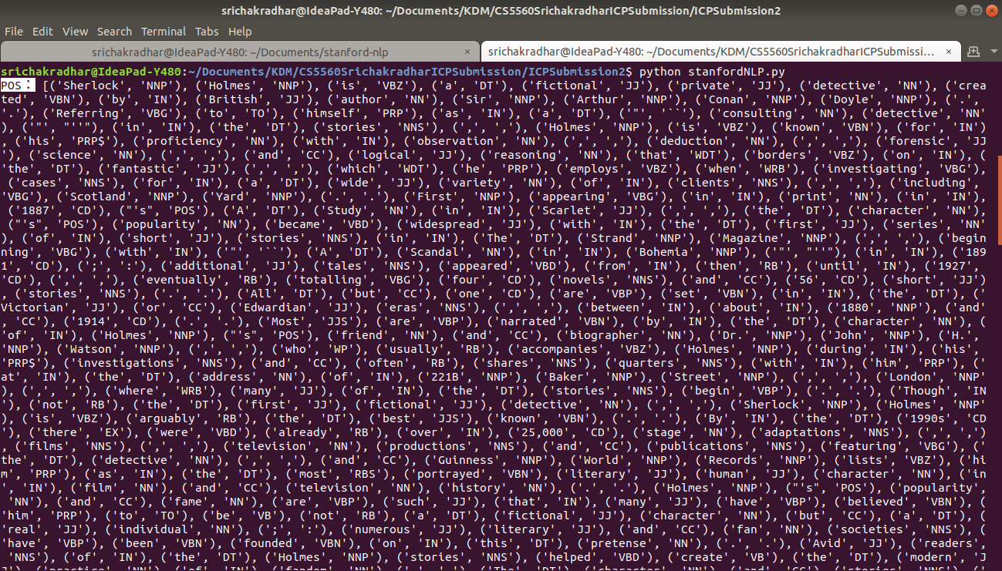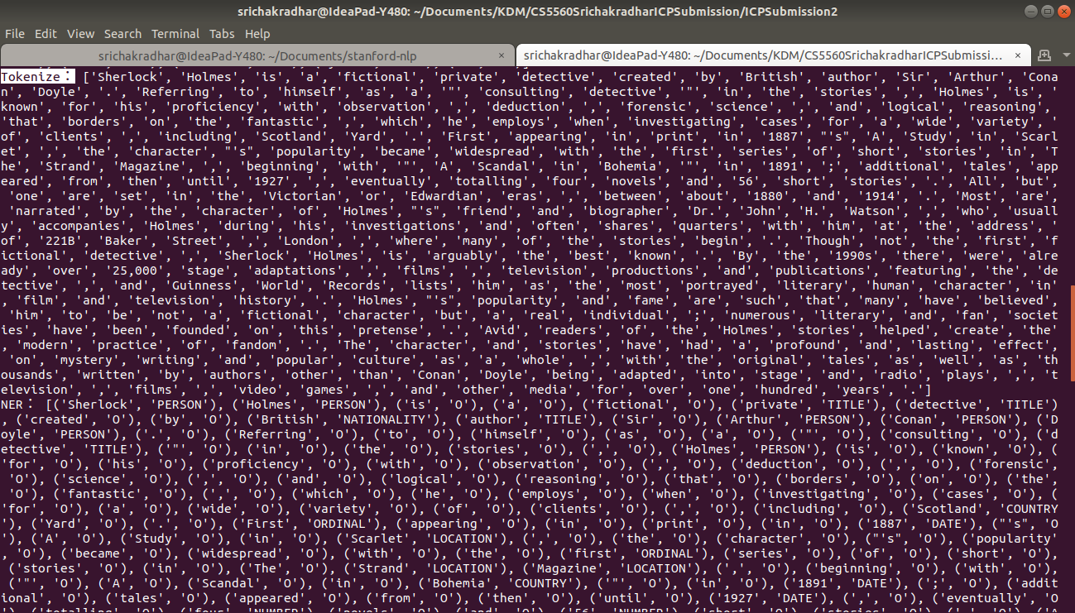

1. **Create an NLP project for the following tasks using CoreNLP**

***Input***: Choose Dataset from the web (a text file)



***NLP Tasks:***

1. *Part-of-speech (POS) tagger*



1. *Named entity recognizer (NER)*



1. *Co-reference resolution system*
2. *Sentiment Analysis*

